Heart disease prediction using different Machine learning methods and Deep Learning Algorithms for older people

Abstract:
Heart disease is one the primary reason for the death rate increase in the world especially in old people. Nearly 17.5 million people die of heart disease every year across the globe. It was estimated that the numbers would increase by 75 million by the end of the year 2040. The doctors or medical professionals in the medical field can predict the chance of heart attack up to an accuracy of 67% only. This unrealistic current situation facing by doctors needs a supporting system for more accurate prediction of heart disease. The machine learning methods and deep learning algorithms provide new opportunities for precise heart disease prediction. This research article offers different plans in machine learning and deep learning with analytical comparison, which may help new and inexperienced medical professionals or researchers in the medical field. Extracting medical data is becoming more and more necessary for predicting and treating high death rates due to heart attacks. Everyday tons of terabytes of data has been produced by the hospitals, and the hospitals will use clinical tests for decision-making about heart data. With the help of a machine learning algorithm Decision tree, we are able to predict heart disease with 89.57% and 76.92% accuracy on train set and test set respectively. We saw the difference between training and testing accuracy is high which makes our model less reliable. Hence the Random Forest algorithm with best hyper parameters is being used to obtain an accuracy of 89.01% for test set and about 87% on training set. The training is done using 4-fold cross validation scheme which ensured our test set accuracy is better to training set accuracy. The accurate algorithm works with rich healthcare data with a high-dimensional data handling system with an intelligent framework that uses different data sources to predict heart disease. In this article, an ensemble-based deep learning model with feature selection was used to improve accuracy. The sigmoid function is used in this article for true class or false class identification, and it is also used to calculate the loss or error in the last year in the neural network. The Adam optimizer is used to adjust the three-layer neural network architecture weights. Our proposed model shows an accuracy of 94% higher than existing methods.
Keywords: Decision Tree, Random forest, Confusion matrix, Machine learning. Artificial Intelligence, Electrocardiogram

Introduction
The complex problem faced by researchers in any field is to predict the outcome. Concerning health care applications, the prediction of any disease before it happens is essential in the medical field. The world health organization statistics say that more than 20 million deaths are happening due to cardiovascular disease. Many high revenue-generated countries worldwide have spent billions of dollars on heart disease treatment per day. Therefore, the system is needed for early prediction of heart disease to treat cardiac patients effectively even attack, or stroke can occur. Heart diseases can be identified by wearing sensors throughout the human body and extracting the data by conducting medical tests. The physicians or doctors will examine the data generated by the sensors and diagnose the patients accurately. The main problem in wearable sensors is signal artifacts may corrupt the data, i.e., data has more missing values, and more noise is present in the sensor device. These two problems impact the system degradation performance, and these sensor devices will generate inaccurate results.
The EMR and sensor data are challenging tasks for monitoring cardiac patients. The extraction of features from the data is also a challenging task for the prediction of heart disease. The need for intelligent systems to predict heart disease automatically fuse the information from sensors and EMR. The data can be analyzed to identify the hidden symptoms of heart problems and diagnose cardiovascular disease using data mining techniques and hybrid models. The hybrid model is the combination of two models. The first model is the feature selection weighting approach to identify the exact feature weight. The second model is the utilization of weights as input for classifiers to predict heart disease exactly. Most heart data have invalid data or repeated data, which means the features are redundant and irrelevant. This kind of data will create confusion among the doctors to define the target class. The time consuming is very high in handling this kind of data. The existing methods have heart disease diagnoses depends on the weighting of features methods. Due to the weights allocation, the uncertain combination of operations may increase mean square error values and a decrease in the prediction model. The theoretical support will not be present if the mean square error values are present. To avoid such situations, the specific weight needs to be applied to the features concerning classification models. The latest technologies in computer science have brought many opportunities for medical researchers, and computer science is used as an instrument for medical professionals to predict diseases. Medical science with artificial intelligence has gained tremendous momentum since the last decade. Machine learning is such a tool used in different domains, and it works on datasets. The best part of machine learning is the reprogramming is possible at any time. It has a lot of strength and has enormous opportunities for medical professionals. The prediction of heart disease has significant challenges because of different parameters utilized for target values. The numerous data types for various conditions to predict heart disease have many approaches, such as Naïve Bayes, KNN, decision tree, random forest, and Neural networks, primarily to indicate any disease with high accuracy. Each algorithm has its specialty for feature classification or accuracy. The neural network has numerous opportunities to reduce the error in heart disease prediction.

2. Literature Survey

The datasets illustration for heart disease are usually raw and inconsistent [4].[ marjia sultana, afrin haider and mohammad shorif]

The pre-processing of the high-dimensional dataset is compulsory for any researchers to reduce it to a common dataset. The extraction of features from the dataset is needed to train the algorithm with less time complexity. Many research articles used time as a parameter and compared other parameters such as accuracy and efficiency. The performance of Bayes Net and SMO classifiers has more efficiency than MLP, J8, and Kstar classifiers. The dataset is mainly collected from WEKA software, and its performance is compared with predictive accuracy and ROC curves. [4].[ marjia sultana, afrin haider and mohammad shorif]

The machine learning methods have their advantages and disadvantages, and feature optimization has been done to achieve higher classification in the decision tree efficiency [5]. Early detection of heart disease has feature utilization and provides a sphere of research for medical professionals for perfect detection of heart disease. This article [6] has collected raw data from electrocardiogram devices and used the dataset to train the neural network for pattern classification. The input and output categories are depressive and non-depressive in the hidden layer to achieve the efficient result. This article also shows the efficiency of 95% is achieved with the neural network training and support vector machine. It is also used to achieve better results. If the data is multidimensional and it's non-linear, this neural network method provides high efficiency concerning other methods.

The robust algorithm can reduce the noise in the dataset, and the redundant data can be eliminated. The deep learning algorithm has a high chance of increasing efficiency and has high accuracy for heart disease detection.

The multilayer perceptron [8] with backpropagation algorithm is used to predict the patient's heart disease. The authors used artificial neural networks and obtained 88.46% and 80.17% for training and validation sets. Overall the accuracy is increased by 1.1% for the training set and 0.82% for the validation dataset. The weighted associative classifier (WAC) [9] predicts the patient heart disease with a GUI interface connected to the patient records. More than 13 attributes and 303 forms are used for training and testing the dataset. The target values are chosen if it's 1, the patient has heart disease.
Similarly, if it's 0, the patient doesn't have heart disease. The classifier used here is CMAR, CBA, and CPAR, and authors obtained an accuracy of 81.51%. The article [10] supports the innovative decision system for heart disease prediction. Mitral stenosis, aortic stenosis, and ventricular septal defects are the three types of heart diseases that are predicted using an artificial neural network decision system. The sound of the heart is gathered for devices such as a stethoscope and microphone. The microphone device is inserted between the stethoscope and PCI card to amplify the sound waves. This ANN-based system identifies the three types of heart disease accurately.

The principal component analysis[5] and regression technique are mainly used for feature selection, and the prediction accuracy is around 92% is achieved for the heart disease dataset. Mainly the feed-forward neural network achieves 95% efficiency. The feed-forward back propagation neural network is used to predict the disease, and it consists of 13 input layers, 20 hidden layers, and one output layer. This network achieves 88% accuracy with 20% of the testing dataset, 20% of the validation dataset, and the remaining 60% of the training dataset,

The following article [2] is a cascade correlation neural network[CNN] that is used to predict the disease. This work accuracy depends on 270 data samples, in which 150 samples are taken for training, and the rest are used to stimulate network architecture. CNN architecture depends on 13 input neurons and one output neuron, and obtained accuracy is 78% for training and 85% for testing with less time complexity.

The article uses feed-forward multilayer perception [12] and supports vector machine to obtain 85% and 87.5% accuracy, out of which 270 samples are used. The division ratio used here is 60 to 40. The number of samples used for training is 162 and for testing is 108. The target values are usually the same (0,1).

The UCI dataset [1] is most predominantly used to evaluate heart attack, and it includes the data of 303 people. It has two classes, one class is for healthy people, and the other class is for unhealthy people. The authors use the binary cuckoo optimization algorithm for feature selection and support vector machine to construct the model. The accuracy achieved is 84.44%, and sensitivity is 86.49%, and specificity is 81.49%.

The deep belief network [3] for heart disease prediction for likelihood percentage is designed in MATLAB software, and the CNN method provides an accuracy of 82%. In [13], the authors used an entropy ensemble of neural networks with recursive feature elimination [EENNRFE] algorithm for feature extraction. The data set used by the authors is Cleveland from the UCI database. The correlation coefficient is found among the features classification and, with the help of artificial neural networks, will measure the mean of an ensemble of neural networks. The accuracy of 85.66% is obtained for training data.

3.Proposed system model
3.1. Data set Used
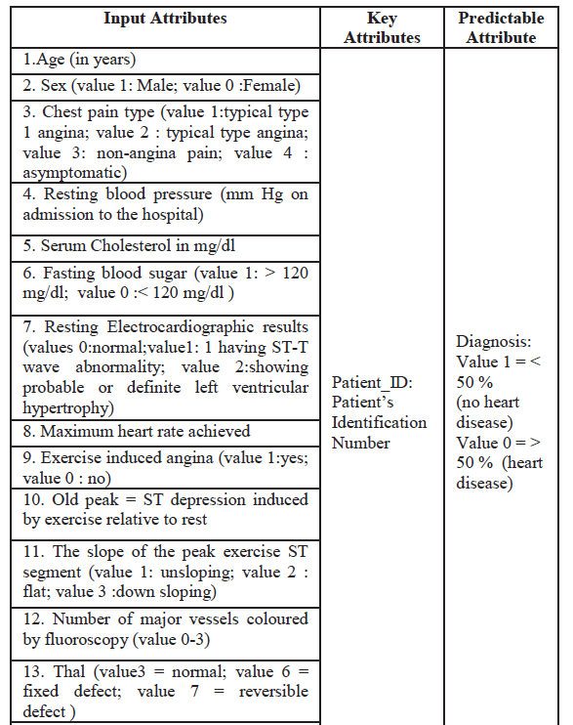
DECISION TREE
It's a tree-like model to make predictions, and it shows an upside-down tree, i.e., it splits the data into multiple sets of data. Each set is further divided into subsets to arrive at a decision finally. It works on nested if then else structure, i.e., each node divides the data into either left or right direction. The top node in the decision tree is called the root node, the node can be classified into a leaf node, and the intermediate nodes between the root and the leaf nodes are called internal nodes.
We imported the required libraries to analyze data, to build the predictive model using different techniques like logistic regression, linear regression, etc. some of the libraries used are NumPy, pandas, math, random, seaborn, and matplot lib.pyplot are used for data analytics or exploratory data analytics [EDA]
For preprocessing the data, the model building we used is SCIKIT-learn which has standard scalar, MinMaxScalar, and Robust scalar to scale down the values in the dataset to between o and 1. The standard scalar makes the dataset value around 0.
Typically any dataset is classified into training and testing, with respect to division ratio, 70:30, 70 % of the data is used for training, and the remaining 30% is used for testing. With the help of pandas library, the excel sheet data is imported into phyton language, later the duplicates in the data are removed using drop_duplicates syntax with considering all the features, later the data is readable and converted or stored into DF data form, or DF. Shape.
Table 2. Features imported into DF dataform.
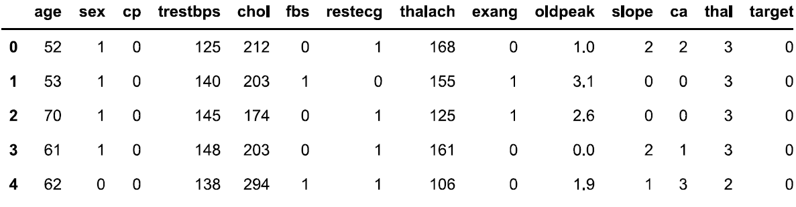

Basically, in the UCI repository, the data set has 1024x 14 rows and columns, i.e., 1024 patients with 14 features are considered in our proposed system, with duplicates. Later the data is cleaned i.e., and we have removed the duplicates the matrix size is converted to 302x14. In the decision tree-based algorithm, the data is divided into X and Y, i.e., the Y terminal has 302x1 matrix values, i.e., 302 patients with one target value. Similarly, the X terminal has 302x13 matrix values, i.e., 302 patients with 13 features expect target variables. All the features are shown in table 1. With the help of skik learn and imported train test split the data into 0.70 and 0.30, i.e., train_size=0.7 and test_size is 0.3, i.e., the training dataset is 70%, and the testing dataset is 30%. After splitting the data, X_training becomes 211x13 matrix size. Similarly, X_test becomes 91x13 matrix size. Again, Y_train is converted to 211x1 matrix size, and X_train is converted to 91x1 matrix size. After setting up the data, the data is fitted into the algorithm, the decision tree classifier with Instantiate with a maximum depth of 3, i.e. X_train and Y_train, is fitted into the classifier. With the help of phy.plus and Graphviz libraries, the classifier is plotted in figure 1.
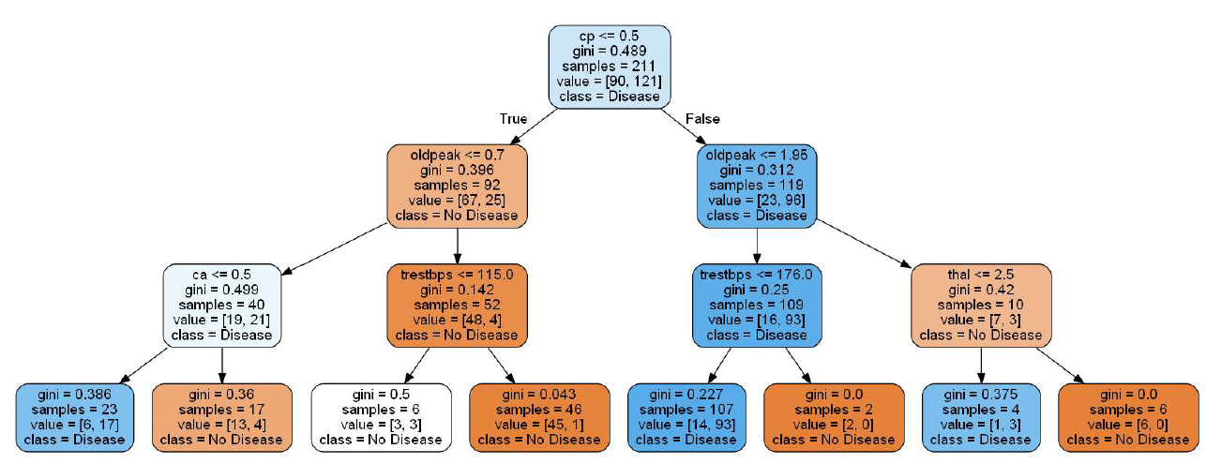
Figure 1.
In figure 1, the last stage is tree leaves. After importing the confusion matrix, the accuracy is only 86%, i.e., true values are 86%, and false values are 14%. This build or prediction model didn't predict the accurate answer.
Confusion matrix
A confusion matrix is a technique for summarizing the performance of a classification algorithm. Classification accuracy alone can be misleading if you have an unequal number of observations in each class or if you have more than two classes in your dataset.
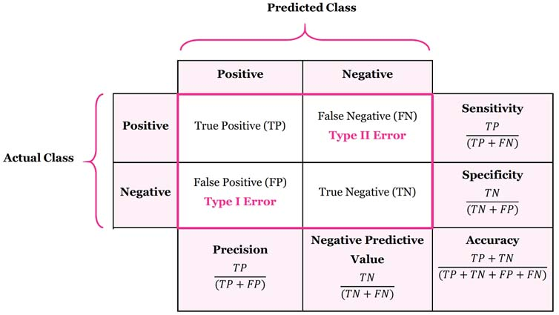
Figure 2. Confusion matrix

The confusion matrix output is
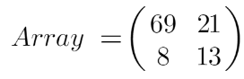 (1)
Accuracy can be calculated as the ratio of correctly predicted labels to the total number of labels, the training accuracy is 86.25%, and the testing accuracy is 76.92% which is not reliable. This model is not efficient, so we have gone for hyperparameter tuning.
Hyperparameter tuning
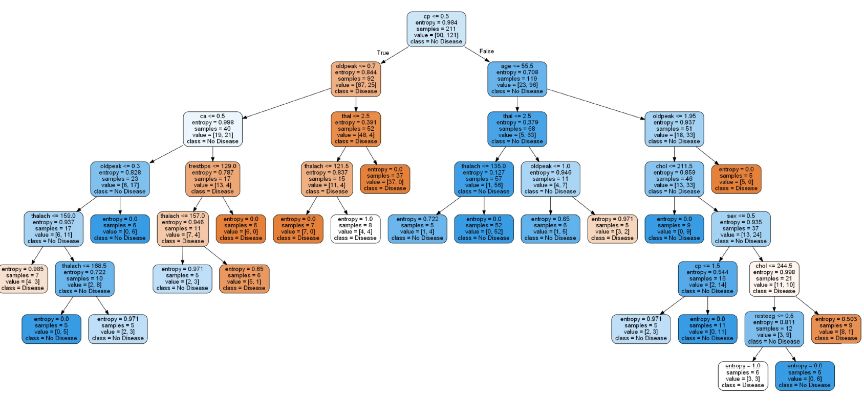
The hyperparameter tuning picks the best features, best parameters with the best layers. This tuning will define the best estimation, the grid search with a maximum depth of 10 using Gini and entropy criteria. The minimum sample leaves are five, with a depth of 10. With these parameters, the data is fit into the decision tree, the training accuracy is 89.5%, and the testing accuracy is 72.5% which is not acceptable. So, therefore, the decision tree is not effectively predictive.
Random Forest Algorithm
the random forest classifier from the ski learn ensemble is imported. After importing the libraries, we tuned the hyperparameters using grid search cv. The best hyperparameters values are found out, such that
maximum features =4,
minimum sample leaf = 5
number of estimators=10,
the training accuracy is 87.67%, and the testing accuracy is 89.07%.
The confusion matrix values for training and testing are shown in below equations

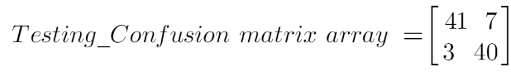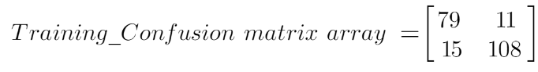

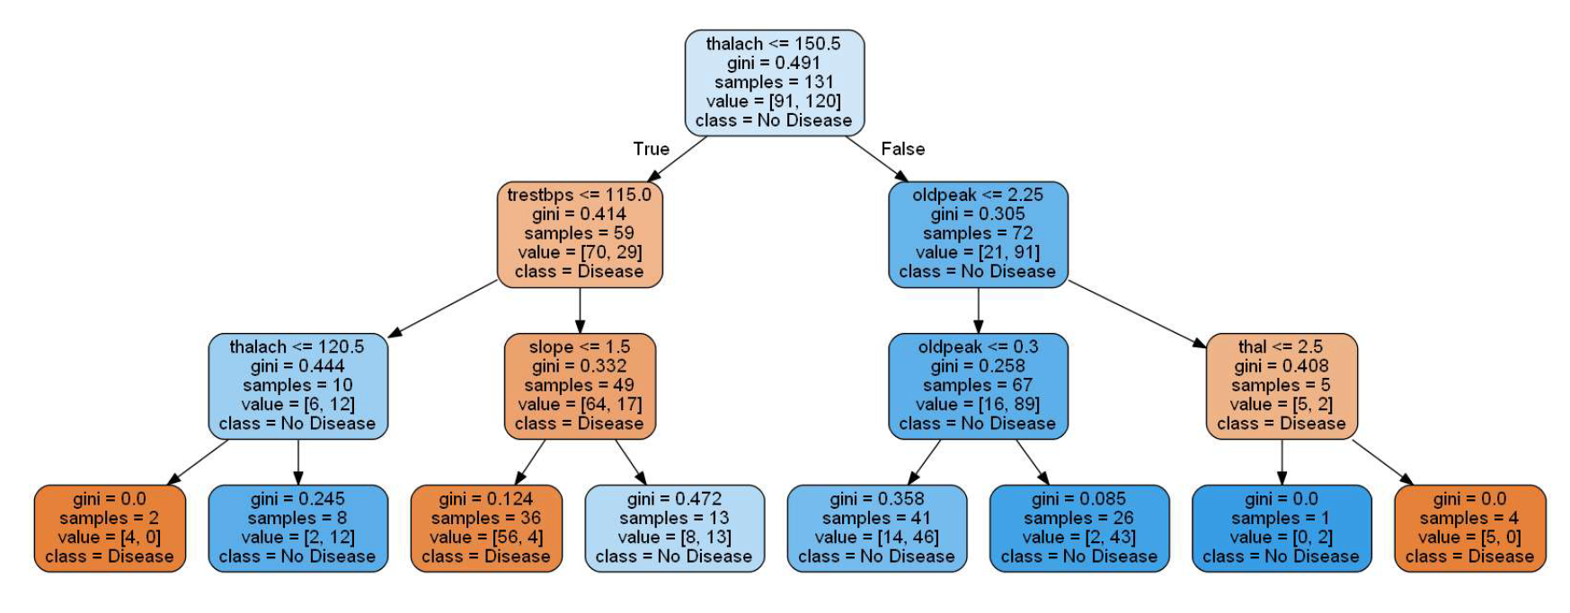

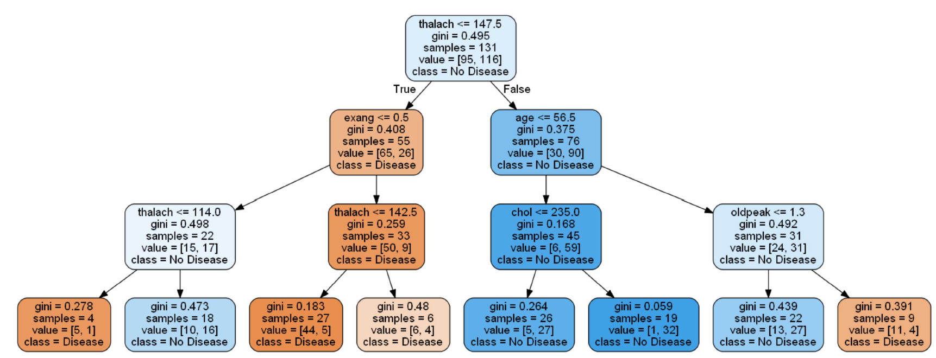

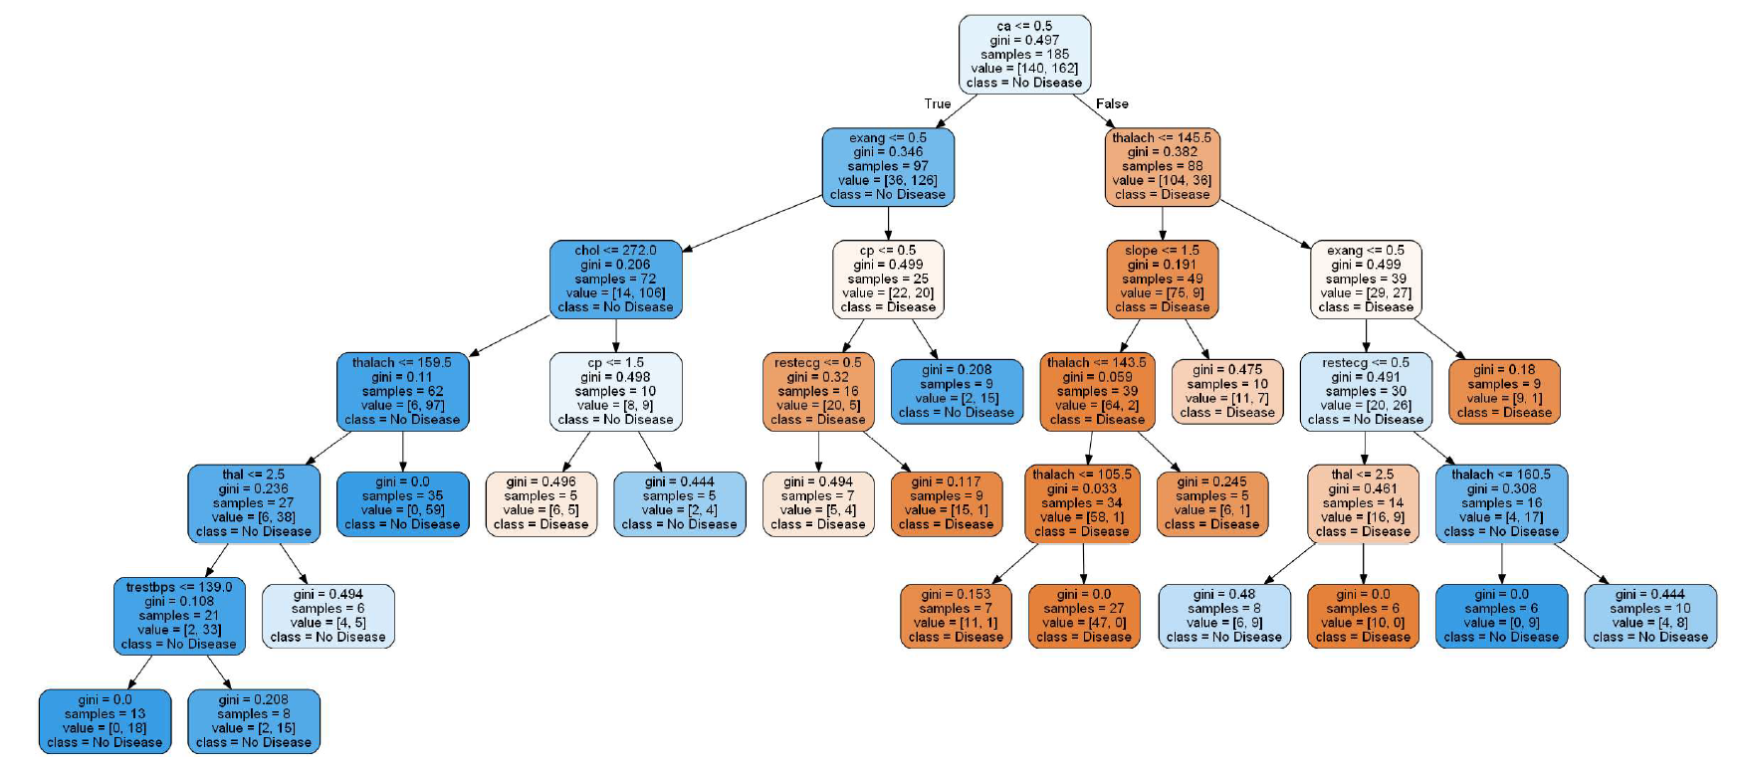

Variable Importance in the decision tree and random forest

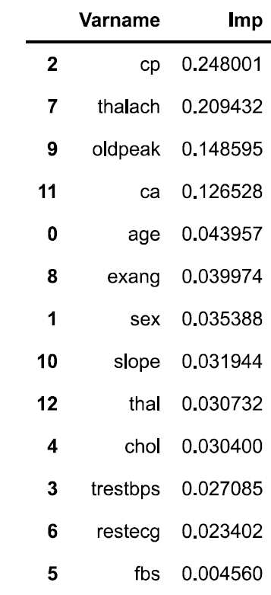
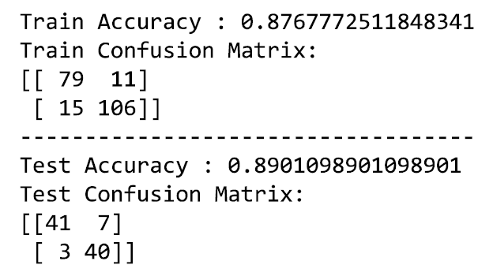
The proposed method using a deep learning model
Since our model will work only for older people, we converted the data with older people by sorting the age above 50. We have seen 230 patients from the UCI repository. After ensembling, the training data is used as 80%, and for testing, data is 20%. The duplicates are removed. The total data from the UCI repository has 1025 entries or patients. We have sorted the patients age above 50. We got 732 entries. Even after removing the duplicates, the 216 entries are used. The number of features we have used for the prediction of heart disease is 13. From there, we generated 60 features, i.e., by combining the features by multiplication or division or adding, 60 features are used to predict heart disease with 216 entries. By using Machine learning techniques like Pearson correlation, linear SVC, Lasso, select K best with chi-z, recursive feature elimination with logistic regression, recursive feature elimination, random forest method, and variance threshold algorithms, out of the above-mentioned techniques, those features only selected present in the methods, from the 60 features only 26 features are selected as final features. So, therefore, the matrix size is converted to 216x26, i.e., 216 patients and 26 features.

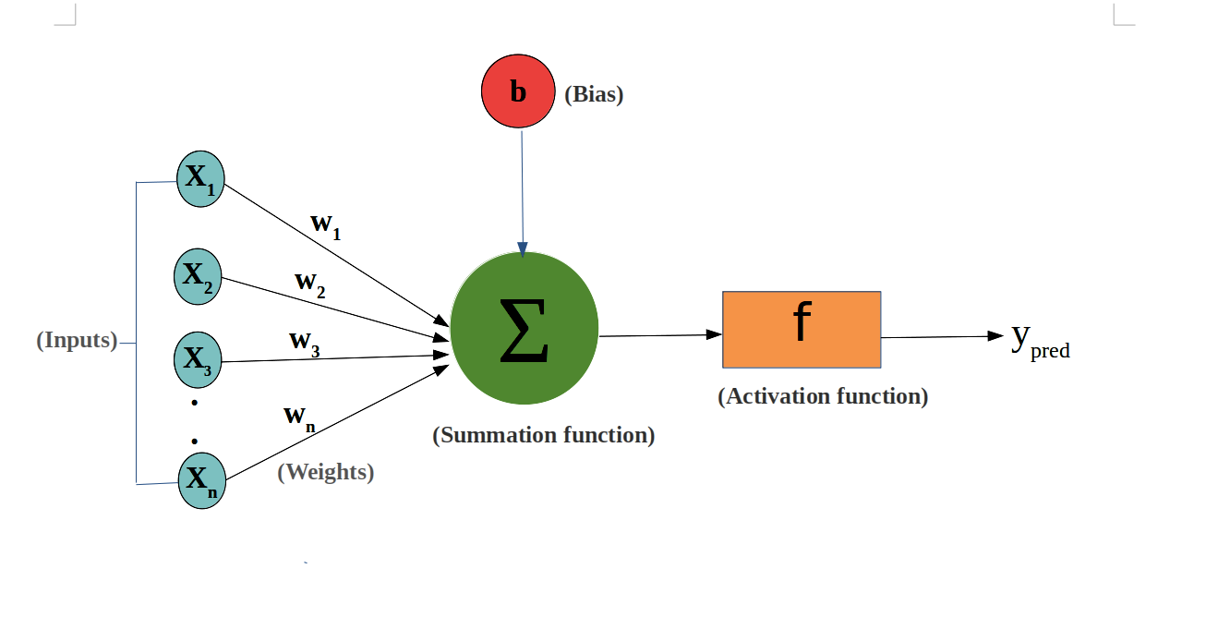
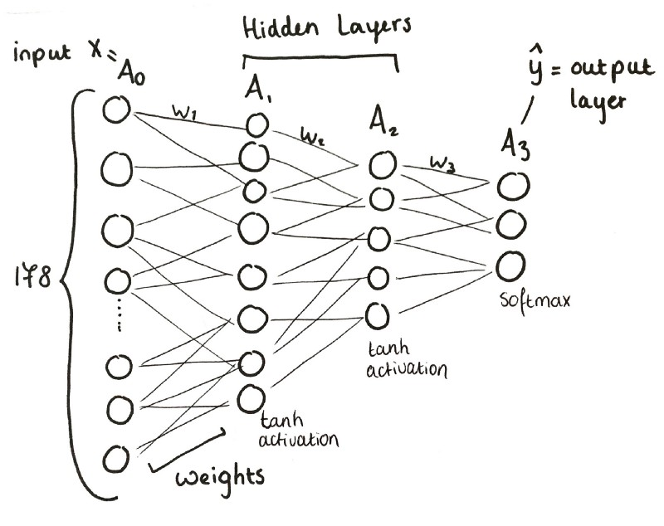
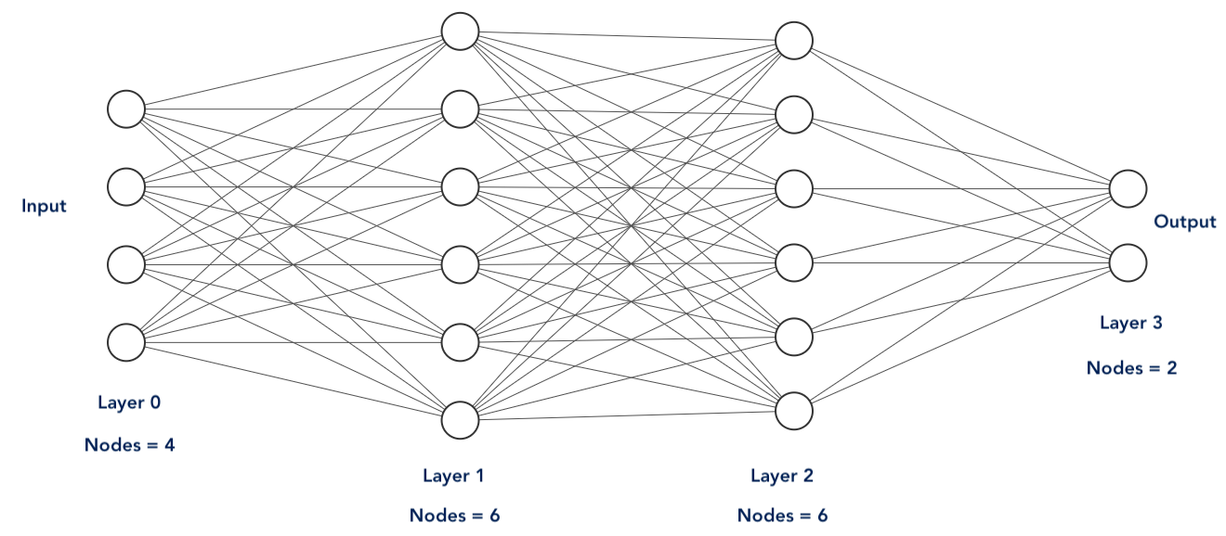

Prevention of Overfitting
we have two methods to prevent the overfitting problem in deep learning.
- Back normalization
- Dropout technique.
Here the number of classes is only two, i.e., the target values are either 0 or 1. To calculate the losses in the last layer, we have used sigmoid function.
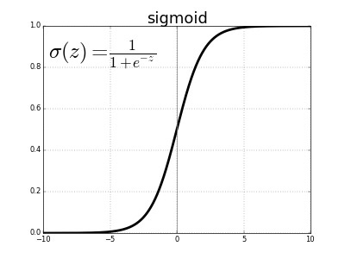
Figure.
Since the binary cross-entropy and backpropagation method is used to adjust the weights, the training of data, the accuracy obtained is 94%. By using the confusion matrix, all ML models are used to compare the accuracy, nearly 20 models are tested, and accuracy is obtained by 94%.
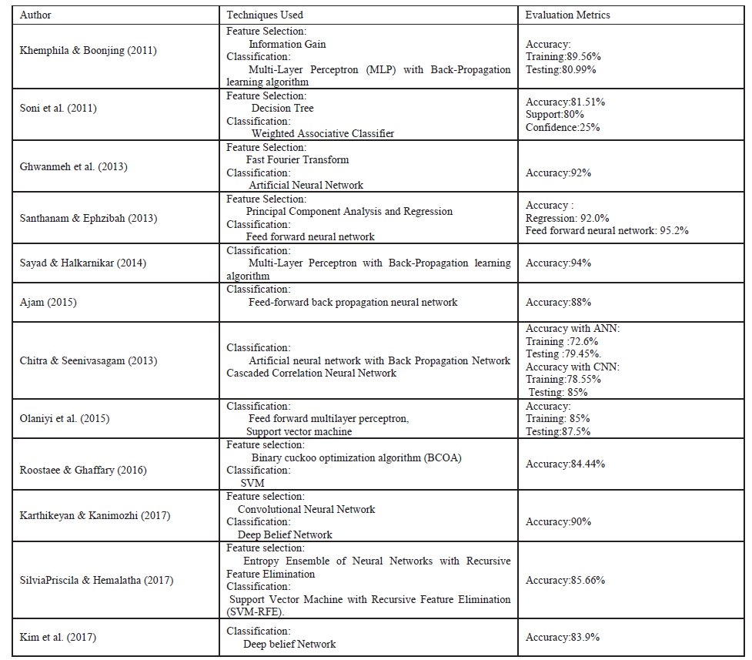

Our paper investigates the different works on machine learning and deep learning techniques to predict the different types of cardiovascular diseases. The feature selection can improve the accuracy, and vigorous tasks, i.e., the relevant and irrelevant can be identified for the proposed system. The neural network is a training method and can predict the relationship between input and output values. It used the backpropagation algorithm as support to predict the disease accurately.

Conclusion
According to the world health organization, nearly 32% of global deaths are due to heart disease. The crucial health problem in society is a heart attack, and this article has used machine learning methods and deep learning. This deep learning method predicts heart disease prediction and compares it with other strategies for different datasets. An efficient and accurate forecast of heart disease are needed, the various ML methods and neural network-based architecture help to find the feature selection and precise prediction. In this article, the ensemble-based framework deep learning model and feature selection are used to improve accuracy. We have obtained an accuracy of 94% by using three layers of neural network.

References
[1] William Carroll; G. Edward Miller, "Disease among Elderly Americans : Estimates for the US civilian
non institutionalized population, 2010," Med. Expend. Panel Surv., no. June, pp. 1–8, 2013.
[2] V. Kirubha and S. M. Priya, "Survey on Data Mining Algorithms in Disease Prediction," vol. 38,
no. 3, pp. 124–128, 2016.
[3] M. A. Jabbar, P. Chandra, and B. L. Deekshatulu, "Prediction of risk score for heart disease using
associative classification and hybrid feature subset selection," Int. Conf. Intell. Syst. Des. Appl. ISDA,
pp. 628–634, 2012.
[4] M. Sultana, A. Haider, and M. S. Uddin, "Analysis of data mining techniques for heart disease
prediction," 2016 3rd Int. Conf. Electr. Eng. Inf. Commun. Technol. iCEEiCT 2016, 2017.
[5] M. Akhil, B. L. Deekshatulu, and P. Chandra, "Classification of Heart Disease Using K- Nearest
Neighbor and Genetic Algorithm," Procedia Technol., vol. 10, pp. 85–94, 2013.
[6] S. Kumra, R. Saxena, and S. Mehta, "An Extensive Review on Swarm Robotics," pp. 140–145, 2009.
[7] T. M. Lakshmi, A. Martin, R. M. Begum, and V. P. Venkatesan, "An Analysis on Performance of
Decision Tree Algorithms using Student's Qualitative Data," Int. J. Mod. Educ. Comput. Sci.,
vol. 5, no. 5, pp. 18–27, 2013.
[8] P. Sharma and A. P. R. Bhartiya, "Implementation of Decision Tree Algorithm to Analysis the
Performance," Int. J. Adv. Res. Comput. Commun. Eng., vol. 1, no. 10, pp. 861–864, 2012.
[9] D. K. Srivastava and L. Bhambhu, "Data classification using support vector machine," J. Theor. Appl. Inf. Technol., 2009.
[10] N. Bhatia and C. Author, "Survey of Nearest Neighbor Techniques," IJCSIS) Int. J. Comput. Sci.
Inf. Secur., vol. 8, no. 2, pp. 302–305, 2010.
[11] J. Schmidhuber, "Deep Learning in neural networks: An overview," 2015.
[12] S. Hochreiter and J. Urgen Schmidhuber, “Long Short-Term Memory,” Neural Comput., vol. 9, no.
8, pp. 1735–1780, 1997.
[13] S. Palaniappan and R. Awang, "Intelligent heart disease prediction system using data mining techniques," 2008 IEEE/ACS Int. Conf. Comput. Syst. Appl., pp. 108–115, 2008.
[14] T. A. Lasko, J. C. Denny, and M. A. Levy, "Computational Phenotype Discovery Using Unsupervised Feature Learning over Noisy, Sparse, and Irregular Clinical Data," PLoS One, vol. 8, no. 6, 2013.
[15] Yuming Hua, Junhai Guo, and Hua Zhao, "Deep Belief Networks and deep learning," Proc. 2015 Int.
Conf. Intell. Comput. Internet Things, pp. 1–4, 2015.
[16] P. De, "Modified Random Forest Approach for Resource Allocation in 5G Network," Int. J. Adv.
Comput. Sci. Appl., vol. 7, no. 11, pp. 405–413, 2016.

